Flood Investigation Report

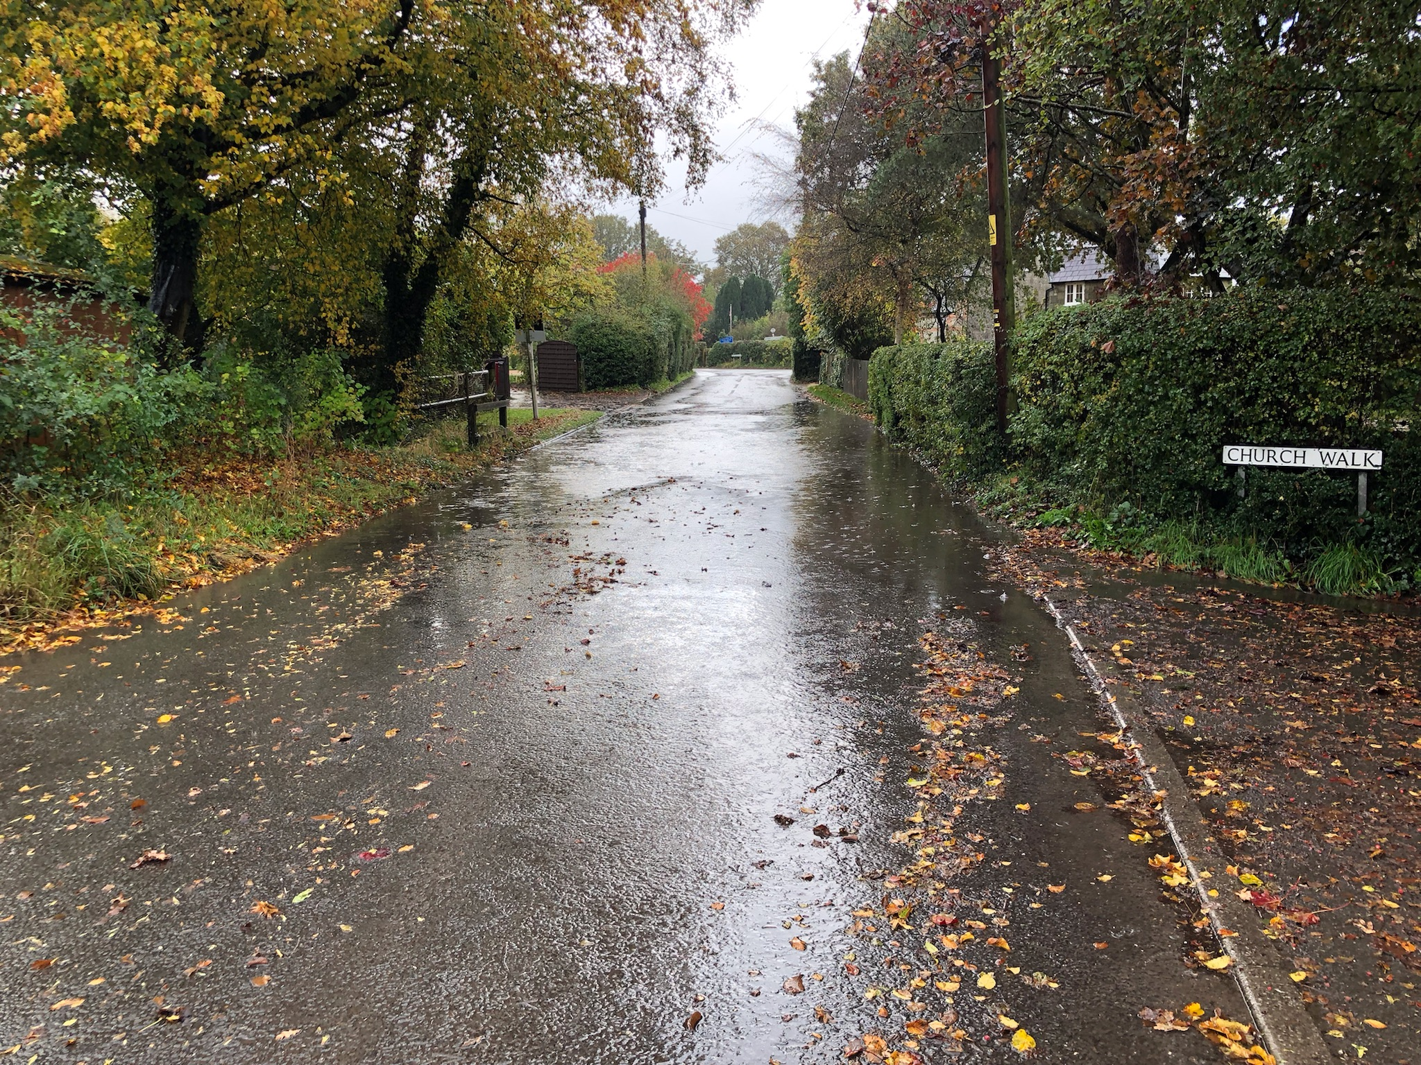
Motcombe
20th/21st October 2021 Flood Event

Table of Contents

1. Introduction 3
2. Risk Management Authority Responsibilities 3
3. Study Area 5
3.1 Description of study area 5
3.2 Geology of study area 6
3.3 Motcombe Flood Alleviation Scheme 7
4. Incident Summary 7
4.1.1. Weather 8
4.1.2. Monitoring 9
4.1.3. Analysis 9
4.2 Locations Affected 9
4.2.1 Church Walk 9
4.2.2 Turnpike Lane 10
4.2.3 The Street 11
4.2.4 Motcombe Road 11
4.3 Analysis of Motcombe Flood 20th/21st October 2021 11
5. Quick Wins 12
6. Recommended Actions 12
7. Next Steps 13
Appendix 1 – Catchment of the Study Area 14
Appendix 2 - Motcombe Flood Defence Scheme 15
Appendix 3 – Environment Agency Rain and River Gauge Locations – Wessex 16
Appendix 4 – Environment Agency Rainfall Analysis, Wessex, 20th October 2021 17
Appendix 5: Dorset Council Rainfall Analysis – North Dorset 20th October 2021 18
Appendix 6 – Location Graphic 19

Introduction
The Flood Risk Regulations 2009 and the Flood and Water Management Act 2010 (the Act) have established unitary and upper tier local authorities as the Lead Local Flood Authority (LLFA) for their area. This has placed a number of responsibilities on the LLFA in relation to flood risk management and in particular Section 19 of the Act which states: When considering if it is necessary or appropriate to investigate a flood event the LLFA will review the severity of the incident, the number of properties affected and the frequency of such an occurrence. Dorset’s Local Flood Risk Management Strategy clearly sets out the criteria to be used when considering a Flood Investigation Report.
Figure 1.1: Flood and Water Management Act 2010 - Local Authority responsibilities
Flood and Water Management Act 2010: Section 19 – Local Authorities: investigations
1) On becoming aware of a flood in its area, a lead local flood authority must, to the extent that it considers it necessary or appropriate, investigate -
a) Which risk management authorities have relevant flood risk management functions, and
b) Whether each of those risk management authorities has exercised, or is proposing to exercise, those functions in response to the flood.
2) Where an authority carries out an investigation under subsection (1) it must -
a) Publish the results of its investigation, and
b) Notify any relevant risk management authorities.

This report has been produced to comply with legislation and to determine the main causes of the flooding. Each affected area will have a number of recommended actions to be taken forward by the relevant Risk Management Authorities (RMA’s) or in some cases, by the land owner or local community action group.

Risk Management Authority Responsibilities

The general RMA responsibilities in relation to flood risk and surface water management are outlined below:
- The Environment Agency (EA) is responsible for managing the risk from the sea, main rivers and reservoirs and has a strategic overview role for all flood risk management, making it a key local partner for Dorset Council especially when managing the risk from combined sources and in the event of a large flood incident. The EA also provides a flood warning service throughout England and Wales in areas at risk of flooding from rivers or the sea.
- Dorset Council as the Lead Local Flood Authority is responsible for the management of the flood risk from ordinary watercourses, groundwater and surface water runoff. It is also responsible for consenting to works on and enforcing the removal of any unlawful structure or obstruction within ordinary watercourses. Dorset Council must also prepare a Local Flood Risk Management Strategy, maintain a record of flood risk assets and undertake investigations. It is also a statutory planning consultee for the management of surface water drainage to major developments (ten or more houses and commercial development of floor space greater than 1000m2 or sites larger than 1Ha).The LLFA also has an overseeing role to ensure that all flood risk is being managed appropriately.
- Dorset Council as the Highway Authority maintains the highway drainage system to reduce the amount of surface water resulting from rainfall falling on the highway. This is achieved by limiting the water on the roads and ensuring that they are kept clear of surface water; including the maintenance of highway gullies and culverts.
- Water and Sewerage Companies (Wessex Water) Water and Sewerage Companies are responsible for managing the risks of flooding from sewer systems providing drainage from buildings and yards.
- National Highways is responsible for managing, maintaining and improving the motorways and trunk roads across England and any associated drainage and flood risk.
- Land/Property Owners that have a watercourse in or adjacent to their land have riparian responsibilities on that watercourse. This means the landowner must:
- Let water flow through their land without any obstruction, pollution or diversion which affects the rights of others.
- Accept flood flows through their land, even if these are caused by inadequate capacity upstream.
- Keep the banks clear of anything that could cause an obstruction and increase flood risk, either on their land or downstream if it is washed away.
- Maintain the bed and banks of the watercourse and the trees and shrubs growing on the banks. The landowner should also clear any litter or debris from the channel and banks, even if it did not come from their land. They must also keep any structures, such as culverts, trash screens and debris grills, weirs and mill gates, clear of debris.

All RMAs have a duty to co-operate and to share information in relation to their flood risk management functions.

Study Area

3.1 Description of study area
The village of Motcombe is located in North Dorset. Geographically the village sits between the towns of Shaftesbury and Gillingham, 2km from the Wiltshire border. Topographically Motcombe lies on the Eastern edge of Blackmore Vale. To the North, East and South the village is bounded by ground rising, sharply in places towards Cranborne Chase and the West Wiltshire Downs. See Figures 3.1 & 3.2 (below).
Figure 3.1: Motcombe location Figure 3.2: Motcombe elevation and drainage
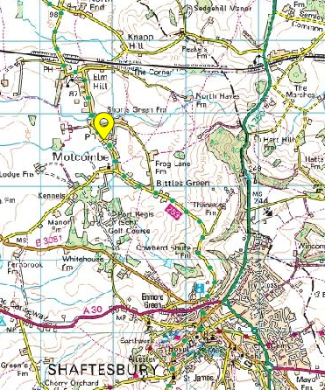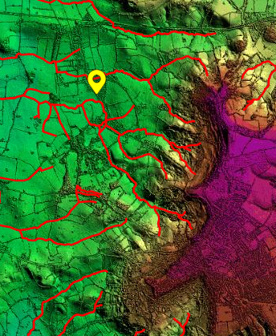
Motcombe sits on the Eastern edge of the River Stour/River Lodden basin. The upper catchment area of these two rivers is some 130km², draining to the south of the South-West Wiltshire downs and to the west of Cranborne Chase. The two rivers join to the south of Gillingham and continue (as the River Stour) south and east through Blandford Forum and Wimborne Minster to outfall at Christchurch. A plan of the wider catchment is at Appendix 1.
The watercourses that transit the village of Motcombe arise from a 5km² catchment area to the east of the village. The land drainage from this catchment enters the village from the south-east and east via four watercourses. The water transits the village and exits as two main watercourses heading west to enter the River Lodden just east of Gillingham, see Figure 3.2, (above).
Wessex Water operate a ‘balancing pond’ (centred on GR: ST 8600 2352) which discharges, via culvert to the watercourse, into the Motcombe catchment. The flow from the surface water sewer system for the north side of Shaftesbury discharge to this balancing pond which then attenuates and slows the flow of the discharge to the watercourse, reducing the risk of erosion to the watercourse.
The land above Motcombe (to the East and South-East) is rural and steep sided. The soil is predominately loam/clay in the body of the catchment becoming more chalk-based as the land rises to the escarpment.
Motcombe is at risk of flooding from a combination of main river, ordinary watercourse and surface water run-off. Parts of the village lie in Environment Agency (EA) Flood Zone 3 (> 1:100 risk of river flooding), see Figures 3.3 & 3.4 (below).
Figure 3.3: Motcombe / EA Floodzone 3 Figure 3.4: Motcombe 1:30 surface water flood risk (EA model, takes no account of existing drainage.)
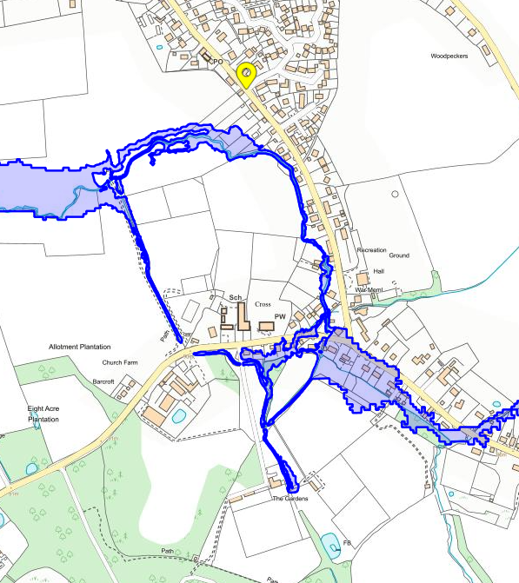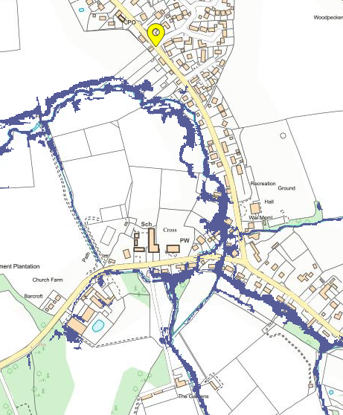
This catchment has a history of flooding. During the 1990’s there were floods and there are reports in the village area from 2000 (3 properties), 2002 (1 property), 2006 (2 properties) and 2018 (1 property).
Motcombe has an active main river alleviation scheme, managed by the EA. See paragraph 3.3 below.

3.2 Geology of study area
The bedrock around Motcombe is predominantly sandstone and mudrock. The Shaftesbury ridge, further east is chalk. Land use is pastoral with some arable agriculture on flatter ground. The surface covering of most of the Motcombe basin is alluvial clay and silt.
Sedimentary bedrock formed approximately 94 to 101 million years ago in the Cretaceous Period, the local environment previously being dominated by warm chalk seas. Superficial deposits are fluvial in origin, they are detrital, ranging from coarse-to fine-grained and form beds and lenses of deposits reflecting the channels and floodplains.
The nature of the surface cover reduces surface water infiltration. Where and when water does infiltrate to the bedrock it is readily transported, forming an important aquifer feeding the wider river catchment.
Figure 3.5- Geology of study area
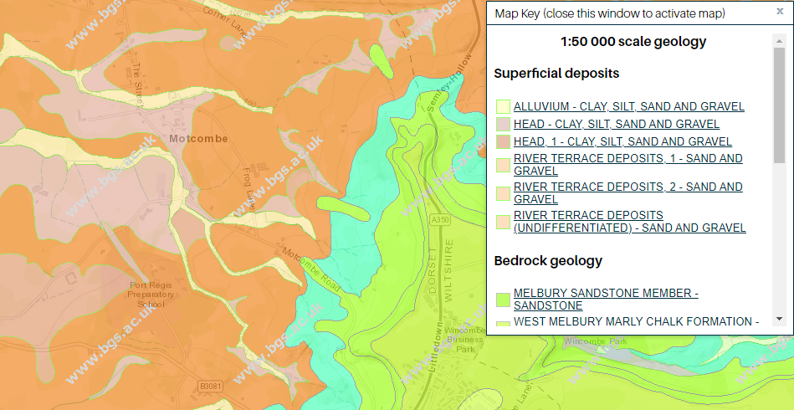

3.3 Motcombe Flood Alleviation Scheme
Following a history of nuisance flooding and further to a consultation and design process, North Dorset District Council installed a flood alleviation scheme (FAS) in 1997. This was designed to give enhanced protection against flooding from the main river up to a 4% Annual Exceedance Probability (AEP), also known as 1 in 25 years flood. The FAS was designed to cope with fluvial (main river) flooding.
The FAS comprises a bypass pipe at Bittles Green culvert along with replacement and additional field culverts. There are localised channel improvements, a replacement footbridge at Barn House and a new open channel stream diversion from an offtake structure (adjacent to a track leading to the rear of Port Regis). This continues under Turnpike Road and re-joins the existing watercourse North West of the village.
A map of this scheme is at Appendix 2. The scheme has operated satisfactorily since commissioning. In 2006 the EA assumed responsibility for ongoing operation and maintenance of the FAS when the drainage changed from ordinary watercourse to main river.

Incident Summary
Motcombe (and the surrounding area) experienced 2 separate, significant rain events, on 20th/21st October and 31st October 2021. The 20th/21st Oct event had the most impact on Motcombe residents but some residents experienced interference in their recovery activities from the second event on 31st Oct. This study notes that the flood mechanics of both events are similar with 20th/21st being the more severe. This event is therefore the focus of detailed examination.
Motcombe, 20th /21st October 2021
Table 4.1 Summary of properties flooded.
(Based on numbers reported to Dorset Council).
Location | Number of properties flooded internally | Incident Date | Main source(s) of flooding during incident
Church Walk | 3 | 20/10/2021 | Main River
Turnpike Lane | 5 | 20/10/2021 | Main River
The Street | 1 | 20/10/2021 | Main River

Readers are requested to note that;
- This report is based only on the information brought to the attention of Dorset Council, it does not guarantee an exact list of affected properties during this reported event.
- Most of the properties reported as suffering from flooding lie within the flood risk zones shown at Figure 3.3 and 3.4.
Much of the following event analysis will draw on the Environment Agency (EA) report ‘EA Flood Hydrology Report, Wessex are, 20 Oct 2021’, published 06/01/2022.
Two pertinent caveats from this report with regard to ‘return periods’ and rainfall intensity are extracted below, as follows:
“…..Customers reading this report must be aware that frequency analysis for large flood events carries a high degree of uncertainty and the return periods provided below are our current best estimates based on available data and methods.”
“…Other locations than those analysed here may have experienced more intense and extreme rainfall. There is also uncertainty in the raw data and frequency analysis methods. Therefore, this analysis should only be interpreted to indicate that the rainfall events were in some locations exceptional and rare.”
4.1 Rainfall

4.1.1. Weather
During the evening of Wednesday 20th October 2021, an occluded front moved from the south west in an easterly direction across southern England, bringing heavy rain and thunderstorms. Rainfall data indicates that rain fell steadily from approximately 5 pm to 11 pm, with a higher intensity period between 7 pm and 9 pm.
A yellow warning for heavy rain was issued by the Met Office and a number of Flood Alerts and Flood Warnings in the Wessex area. The Flood Guidance Statement at the time indicated a “yellow” (low) overall flood risk for the area: a medium likelihood of minor impacts (“heavy rain may lead to some local flood impacts from late afternoon”).

4.1.2. Monitoring
Objective rainfall information is provided by monitoring gauges. The locations of the EA gauges in the Wessex area are shown in Appendix 3, the information from these gauges for 20th October 2021 is at Appendix 4.
The LLFA also operates a local, if relatively sparse, network of rain gauges, optimised to capture and report intensity of rainfall. The nearest sensor to Motcombe is on Rope Farm, 7km north-west of Motcombe. The information from this gauge for 20th October is at Appendix 5.

4.1.3. Analysis
With regard to rainfall across Wessex the EA rainfall analysis (highlight added) states that;
In many locations, the rainfall was unexceptional (1 in 2 to 1 in 5 return period). However, at Raymonds Hill, the estimated return period was greater than 1 in 150 for the 1-hour duration rainfall.
Moderately extreme rainfall was also recorded at Chard Snowden Hill, with a return period of 1 in 10 to 1 in 25 for the 3- and 6-hour duration rainfall. These estimates indicate that the rainfall was locally extreme, but not consistently heavy across widespread area.
The LLFA gauge (Rope Farm, 7km north-west of Motcombe) shows a 36-hour event (1800hrs Tue 19th – 2359hrs Wed 20th October 2021) with 68mm of rain falling in this period. The peak intensity of rainfall in this period was a short (10-20 minute period) where the rate of rainfall was >65mm/hr. The UK Meteorological Office categorises rainfall above 50mm/hr as ‘violent rain’ (the most severe category).
The LLFA conclusion from this analysis is that the total amount of rain landing in the Motcombe area over the period 19th – 21st October 2021 was not unusual. It was the intensity of the rainfall over some of this period that was sufficient to overwhelm drainage systems in multiple locations across North Dorset and into Wiltshire.

4.2 Locations Affected
The areas predominantly affected during the flooding event of the 20th October 2021 were Church Walk, Turnpike Lane (as far as Motcombe C of E school), The Street and Motcombe Road.

4.2.1 Church Walk
Figure 4.2.1.1 Church Walk in flood
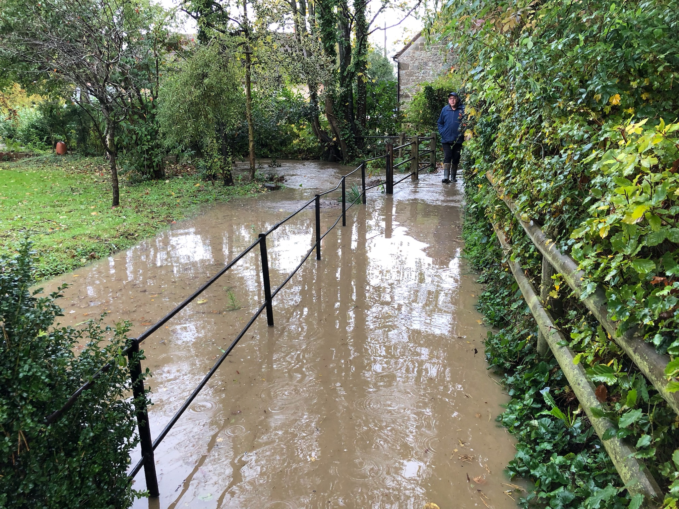
Church Walk is a paved footpath approximately 60m long with an open watercourse running beside it. Approximately half-way along the path the ordinary watercourse through the village merges from the east, forming the main drainage route North from the village. Prior to the installation of the flood alleviation scheme this was the main route for water to exit to the North of Motcombe.
Three properties in Church Walk reported internal flooding. Residents reported the source of the water to be the main river. The mechanism appears to be excessive flow combined with constricted capacity to cause overtopping.
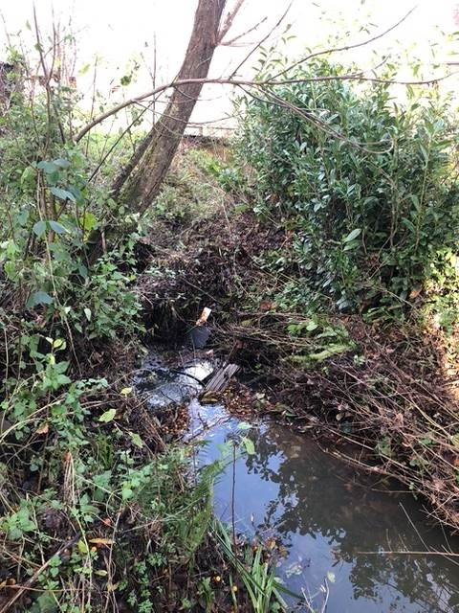
Figure 4.2.1.2 Side of No.8 Church Walk
There was evidence of a build-up of trash in the main river running alongside Church Walk, some of which arrived with the heavy rain of 20th/21st October. Figure 4.2.1.2.is a photograph taken after 20th October of the main river An approximate location of this point is shown in the Location Graphic at Appendix 6.
Regular clearance and maintenance of watercourses is essential to ensure their optimal performance.
Responsibility for watercourse maintenance rests with the riparian owner. The EA use their permissive power to maintain the formal flood alleviation channel.

4.2.2 Turnpike Lane
Five properties on Turnpike Lane, between Church Walk and past the village school, suffered internal flooding from the road into the front of their properties and from water entering their gardens and then into the rear.
The water on the road was reported by residents to have come from the main river (running south to north), as it runs under Turnpike Lane and exits north alongside Church Walk.
Evidence for the source of water at the back of the properties along Turnpike Lane is uncertain. Residents report water overtopping to the right hand bank of the FAS at GR ST 8489 2517. The EA inspection post event could find no evidence of flow routes over the embankment.
There is also uncertainty as to the condition / connectivity of the culverted ordinary watercourse running to the rear of the properties due to possible alterations to its alignment and capacity
The FAS continues another 30m before entering a culvert under a track to Port Regis School at GR ST 8486 2517. It then runs a further 70m before crossing Turnpike Lane via another trash screen and culvert at GR ST 8478 2519. The main river then heads North through fields to discharge downstream of the community.
Figure 4.2.2.2 EA - Motcombe screen before rain 20th/21st Oct 2021
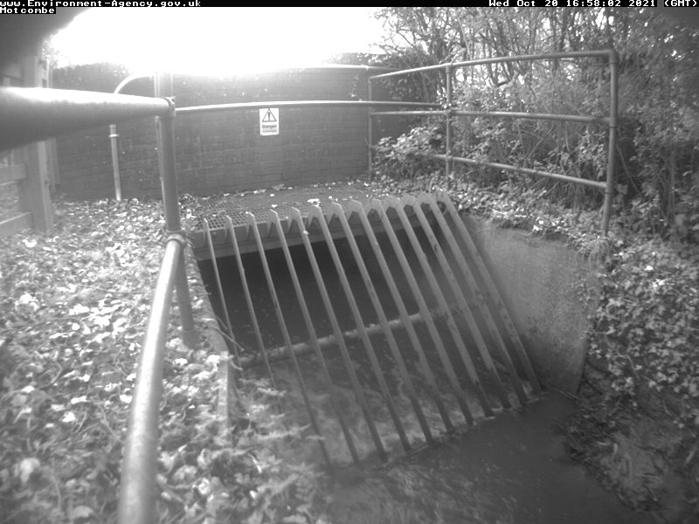
Build-up of trash against these screens has been cited by Motcombe residents as a contributing/exacerbating factor during the flood event.
The EA state that the Turnpike Lane trash screen was cleared in daylight on 20th October in anticipation of the forecast weather. EA staff also reported a large volume of surface water entering the system, something their staff had not observed previously.
The EA Duty Log for 20th / 21st October 2021 shows ‘gang on site’ at Motcombe at 01:18hrs on 21st Oct to ‘clear screen’. EA also have a camera on the Turnpike Lane culvert and provided the image at Figure 4.2.2.2.
Residents report debris from EA clearance operations left alongside the main river scheme where some re-entered the system due to elevated river levels over the next few days.

4.2.3 The Street
Figure 4.2.3.1 - The Street
One property, backing onto the main river in The Street reported internal flooding due to ground water upsurge. Another property in The Street suffered external flooding from water coming from the direction of the main river.

4.2.4 Motcombe Road
A single property reported external flooding from the watercourse along their rear boundary. This is consistent with the overall theme of watercourses in spate, overtopping and causing flooding along their route.

4.3 Analysis of Motcombe Flood 20th/21st October 2021
The principal cause of the flood events in Motcombe on the night of 20th – 21st October 2021 was the intense but relatively short rainfall event. This rain fell on a steeply sloping catchment with limited routes for drainage, all of which flow through Motcombe. Other contributing factors included a main river blockage, exceedance of the main river channel capacity and to a lesser extent the integrity of a culverted ordinary watercourse. As a result, the existing drainage system in Motcombe was unable to cope with this rainfall event.
The watercourses through Motcombe were in spate and most coped well enough with the high flows. Problems arose were there were constrictions (such as at culvert entrances), constraints (such a steep sided or sharply curved banks), impedence to flow (from debris) and junctions where watercourses merged.
Other anecdotal evidence pointed to possible contributions to the volume of surface water in the Motcombe catchment from the following sources;
- Wessex Water balancing pond (GR: ST 8600 2352, to south of Quoits Copse). This has been discounted following engagement with Wessex Water.
- New housing development at Littledown, north of Shaftesbury and to west of A350. This is followed up as detailed below.

Quick Wins
As part of the on-going investigation, a number of quick win schemes to reduce the impact of flooding were identified, that could be implemented quickly by the RMA’s or landowners within a short timescale and at relatively low cost. These have already been completed as this report has been progressed and are summarised in the table below
Table 5.1 Quick Win actions for Motcombe
Number | Quick wins
5.1 | - Removal of debris / obstructions in main river alongside Church Walk [Riparian owners / local community]
5.2 | - Ensure main river debris is removed regularly and to a point where it is not readily swept back in. [EA/Riparian owners/Local Community]
5.3 | - Conduct internal (camera) survey of culverted watercourse to the South of and under Turnpike Lane [EA]
5.4 | - Confirm surface water drainage conditions have been met for new development at Littledown, Shaftesbury [LLFA]

Recommended Actions
As a result of this investigation report, several recommendations have been made for actions to be taken in specific locations. These are either as a result of initial site or desktop investigations, or the continuation of works or investigations already in progress. There are also a series of general actions recommended to be considered in all locations. See Table 6.1 (below)
Table 6.1 Recommended Actions for Motcombe
Action Number | Action By | Recommended Action | How
6.1 | Local Community | Increase community resilience to flood events. | Review current Parish sandbag arrangements.  Develop the Motcombe Flood Management Plan with the Parish Council and Parish Flood Warden.  Ensure that the location of any vulnerable residents is known.
6.2 | Property Owners | Consider flood risk to properties.  Maintain watercourses within or on property boundary | Discuss the responsibility to protect their property from flooding and having sandbags available at short notice.  Ensure riparian owned watercourses are maintained without obstruction to flow.
6.3 | EA | Establish most appropriate flood risk management solutions for the Upper Stour including Motcombe | EA to secure funding to review the main river hydraulic model and assess the competency of the main river FAS.
6.4 | LLFA | Continue to engage with landowners in Motcombe catchment to reduce surface water run-off and soil erosion | Utilise the Farming and Wildlife Advisory Group specialist service / environmental charity support where possible.  Leverage rural farm payments were possible/applicable to promote Natural Flood Management interventions
6.5 | EA | Investigate applicability of EA-funded property level resilience programs | Provide information to property owners such as the ‘Blue Pages directory’ measures.  Provide details of EA Flood Warning Service to local community

Next Steps

The next steps following this report will be for Dorset Council as the LLFA to ensure that the recommended actions are taken forward by the identified Risk Management Authorities. Dorset Council will monitor actions through regular reviews, whilst working in partnership with the EA, and the local community

Appendix 1 – Catchment of the Study Area
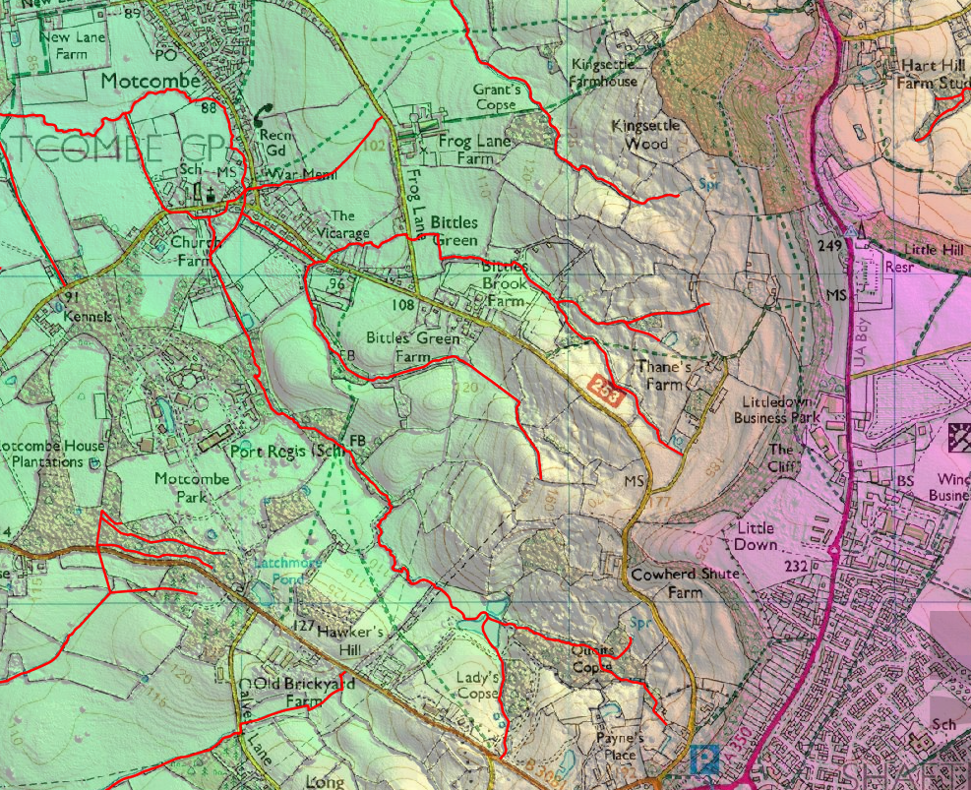

Appendix 2 - Motcombe Flood Defence Scheme
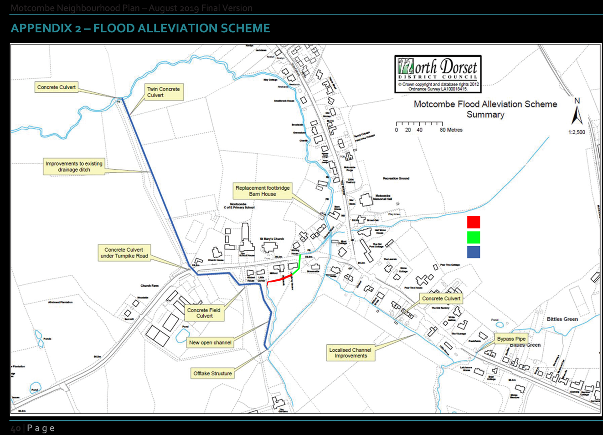

Appendix 3 – Environment Agency Rain and River Gauge Locations – Wessex
[Source: EA Flood Hydrology Report, Wessex area, 20 Oct 2021, published 06/01/2022]
For the purposes of this report the gauges around the upper reaches of the catchment for the Rivers Stour and Lodden are the most pertinent. These are; Gillingham, Wincanton and Penridge. Tisbury and Compton Abbas Airfield are close enough for useful context.

Appendix 4 – Environment Agency Rainfall Analysis, Wessex, 20th October 2021
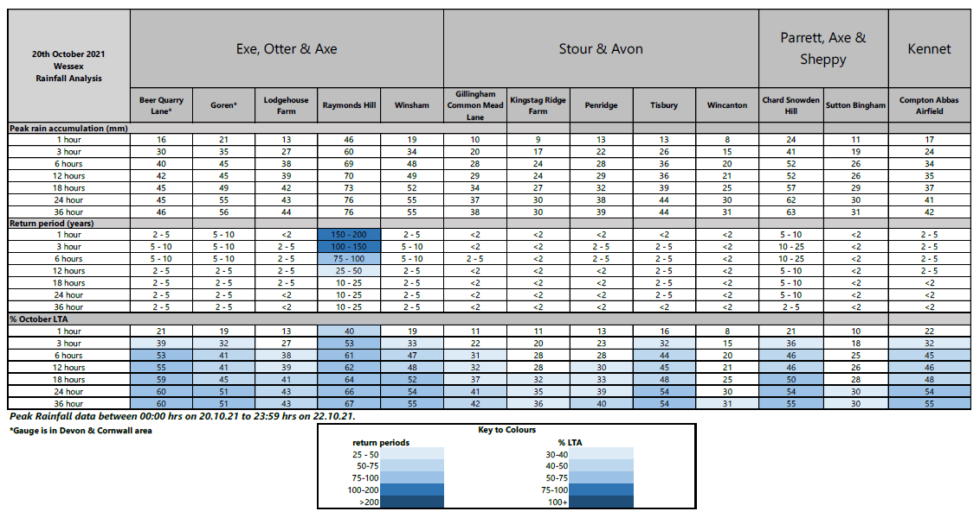
[Source: EA Flood Hydrology Report, Wessex area, 20 Oct 2021, published 06/01/2022]

Appendix 5: Dorset Council Rainfall Analysis – North Dorset 20th October 2021
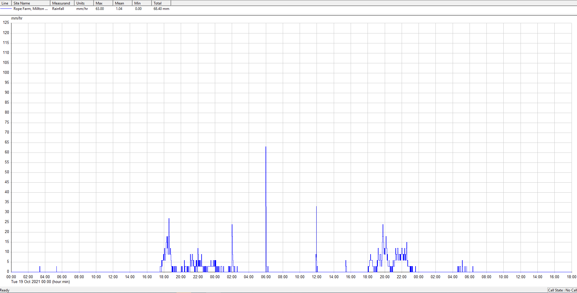
36 hr Event: 68.2mm = 1 in 18 years or 5.56 AE

Appendix 6 – Location Graphic

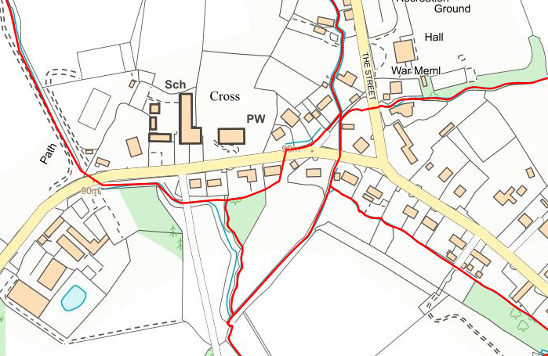
Motcombe Flood Alleviation Scheme
Culvert status uncertain
Trash Screen
GR: ST 8478 2519
Culvert
GR ST 8486 2517
Blockage in main river
Turnpike Lane
Church Walk
Suspected overtopping

[Intentionally Blank]

Floods are often defined according to their likelihood of occurring in any given year. AEP is the chance or probability of a natural hazard event (usually a rainfall or flooding event) occurring annually. This is usually expressed as a percentage. Another commonly used definition is the '1 in 100 year flood'. This refers to a flood level or peak that has a one in a hundred, or 1%, chance of being equalled or exceeded in any year. For such an event the 1% AEP, term is preferred because it can avoid the common misconception that a '1 in 100 year flood', can only occur once every 100 years; or that you are 'safe' for another 100 years after you experience such an event.
‘Flooded’ properties are where water has entered the property (or outbuildings). ‘Affected’ properties are where water has incurred onto land or open ground belonging to a property but not into buildings.
As recorded via the Flood Online Reporting Tool (FORT).

